Symposium/Forum
TITLE
Cultural Influences in Global Testing: Holistic Approach to Inference Validity

ABSTRACT
This symposium integrates and extends recent thinking in global testing to offer a holistic perspective on the area. We recognize the complexity of culture and distinguish four areas of predictors (selection tests) and criteria (job performance) that culture impacts: language, conceptualization of the construct, response tendencies, and applicant reactions.

PRESS PARAGRAPH
The current symposium integrates and extends recent thinking in global testing to offer a holistic perspective on the area with a special focus on inference validity. First, we recognize the complexity of culture and suggest alternate ways of “splitting the pie”. Second, we distinguish four areas of the predictor that culture affects: language, conceptualization of the construct, response tendencies, and applicant reactions. Third, we extend the above listed four areas of cultural influence to the criterion side. Although each contributor addresses a different piece of the puzzle, together the presentations paint a comprehensive picture of cultural influences in global testing.

Symposium/Forum Summary

Martin Lanik and Joe Jones (Co-Chairs)
Development Dimensions International

Globalization has instigated research interest in cultural influences on international use of tests. Developments occurred especially in areas of test translation, cultural adaptation, and statistical tools to test for equivalence. Moreover, our conceptualization of culture broadened with the realization that equating culture with national boundaries is often meaningless in today’s culturally complex world. Integrating and extending the recent thinking in global testing, the current symposium/forum offers a holistic perspective on the area with a special focus on the validity of test-related inferences.
Figure 1 displays our conceptual model of cultural influences in global testing. The model consists of three parts: culture, predictor, and criterion. To set the stage, Myers and colleagues discuss the importance of culture in organizational behavior and offer ways to apply value-based tools in selection and performance appraisals. Although culture has been defined in many ways, we favor Chao and Moon’s (2005) distinction between geographic, demographic, and associative aspects of culture and point to the importance of considering such aspects in addition to the commonly studied country-level differences. For example, Bartram and Pratt and colleagues report variation across countries in gender differences on several personality traits and in the endorsement of comparative biodata items. Additionally, the Myers et al. paper highlights the emergence of a global layer of culture, which is beginning to receive attention (e.g., Erez & Gati, 2004).
We conceptualize the predictor as a form of assessment believed to predict job performance. We identified four areas of cultural influence on the predictor side: (a) language, (b) conceptualization of the measured construct, (c) response tendencies, and (d) reactions to the tool. Language is perhaps the most obvious area – different languages are spoken in different cultures and different languages possess their own idiosyncrasies. The International Test Commission (ITC) has issued Guidelines on Test Adaptation to ensure the comparability of different language versions of a test. The Bartram paper demonstrates how these guidelines were utilized in translation and adaptation efforts of a personality measure to 28 languages.
Cross-cultural use of tests also introduces variation in the conceptualization of the measured construct. Pratt and colleagues highlight cross-national differences in educational systems, extracurricular activities, and opportunities for leadership experiences and discuss how such differences influence people’s understanding of biodata questions. Different reference groups across cultures may influence the relative strength of the measured construct in that culture (cf. Heine, Lehman, Peng, & Greenholtz, 2002); the Pratt et al. paper argues that readily-accessible, work-relevant information works best across cultures because of similarity in applicants’ frame-of-reference.
Although addressed more specifically on the criterion side, culture also influences how people respond to test questions. The tendency of US nationals to endorse extreme points of the rating scale is often contrasted with the tendency of the Chinese to endorse the middle points (e.g., Cheung & Rensvold, 2000). Cultural differences also exist in what is considered a socially desirable item and the direction of endorsement of desirable items (Heine & Renshaw, 2002). We call for more cross-cultural research in the area of social desirability and faking.
Applicants’reactions is another area of cultural influence; these are largely determined by local selection practices and cultural differences in fairness perceptions (Steiner & Gilliland, 2001). Budden and colleagues examine test-taker’s reactions to an online test battery composed of situational judgment, dispositional, and biodata items across samples from Asia, Latin America, and the United States.
The major purpose of a selection tool is to predict job performance to guide administrative decisions. The common oversight of the criterion (Austin & Villanova, 1992), has happened also in the cross-cultural arena. Although many articles exist on the cross-cultural functioning of tests, only a few studies examined cultural influences in job performance ratings. As such, Jones and Lanik highlight some of the challenges with international use of job performance rating scales often used in validation studies. For example, specific language issues are associated with translating competency-based performance rating scales. Earlier research by Ployhart, Wiechmann, Schmitt, Sacco and Rogg (2003) suggested that supervisors in different countries conceptualize the construct of job performance differently. Rating biases also differ across cultures as may supervisors’ reactions to the performance metric.
As testing becomes more global, the need to study cultural influences increases. Global testing has witnessed several lines of cross-cultural research; the time to integrate these into a unified model has come. Although each contributor addresses a different piece of the puzzle, together the presentations paint a comprehensive picture of cultural influences in global testing with a special focus on the validity of test-related inferences.
References
Austin, J. T., & Villanova, P. (1992). The criterion problem: 1917-1992. Journal of Applied
Psychology, 77, 836-874.
Cheung, G. W., & Rensvold, R. B. (2000). Assessing extreme and acquiescence response sets in
cross-cultural research using structural equations modeling. Journal of Cross-Cultural
Psychology, 31, 187-212.
Chao, G. T., & Moon, H. (2005). The cultural mosaic: A metatheory for understanding the
complexity of culture. Journal of Applied Psychology, 90, 1128-1140.
Heine, S. J., Lehman, D. R., Peng, K., & Greenholtz, J. (2002). What’s wrong with cross-cultural
comparisons of subjective Likert scales? The reference-group effect. Journal of Personality
and Social Psychology, 82, 903-918.
Heine, S. J., & Renshaw, K. (2002). Interjudge agreement, self-enhancement, and liking: Cross-
cultural divergences. Personality and Social Psychology Bulletin, 28, 578-587.
Ployhart, R. E., Wiechmann, D., Schmitt, N., Sacco, J. M., & Rogg, K (2003). The cross-cultural
equivalence of job performance ratings. Human Performance, 16, 49-79.
Steiner, D. D., & Gilliland, S. W. (2001). Procedural justice in personnel selection: International
and cross-cultural perspectives. International Journal of Selection and Assessment, 9, 124-
137.

Figure Caption
Figure 1
Conceptual Model of Cultural Influences in Global Testing

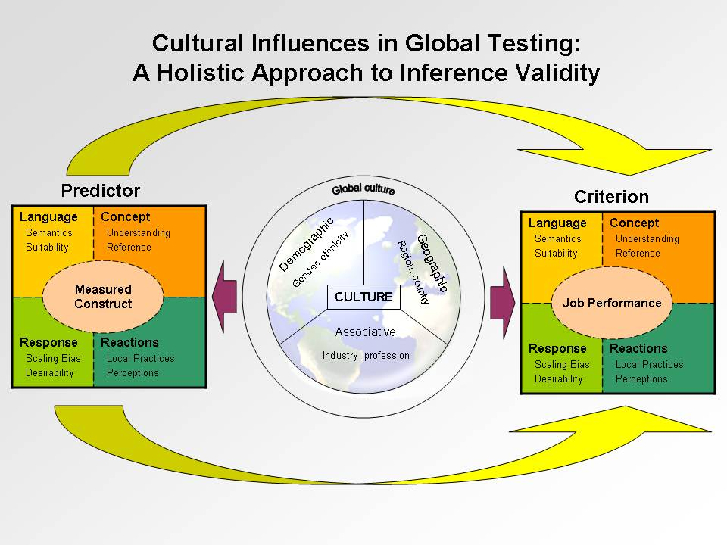
Core Organizational Values: Can They Transcend Culture?
Tara Myers and John Szypula
CorVirtus

Apryl Rogers Brodersen
Metropolitan State College of Denver

Schein (1992) defines culture as “the accumulated shared learning of a given group, covering behavioral, emotional, and cognitive elements of the group members’ total psychological functioning.” In particular, culture is created through (a) shared norms, values, rituals, traditions, etc.; (b) structural stability of the group; and (c) a “patterning” or “integration” that ties together various elements of a culture at a deeper (perhaps unobserved) level (Hofstede, 2001; Schein, 1992).
Such culture provides the context for circumstances and situations that occur in the workplace. Thus, it is important to understand how culture affects individual behaviors and attitudes in order to create work environments that (a) tap into the best human potential to drive business, with a particular emphasis on systems and instruments that do not exclude people from particular cultures, and (b) optimize enterprise performance by exploiting the cultural strengths within the enterprise. This is particularly relevant to companies operating within and/or across more than one culture, such as large companies attracting a workforce from a variety of different cultures (ethnic, socio-economic, demographic, etc.) and multi-national companies with unique or redundant operations dispersed across a multitude of countries.
A company that operates across national or multi-national cultures will necessarily deal with multiple perspectives, values, and norms. Nonetheless, it is possible for it to have a unique culture of its own that is strong enough to transcend those differences. In our experience, this happens in two main steps. First, the company taps into a larger global culture (i.e., core common values shared across all cultures). Second, it manifests that global culture in a unique corporate culture.
Transcending Cultural Differences
It is possible to have unifying ideals that pull different cultures together. Such a global culture exists, as Schein and Hofstede have described, through shared values. Extensive research, including philosophical and religious, has been done with respect to such shared values. Through a comprehensive review of the research, Peterson and Seligman (2004) identified six core values that are shared across all humans: wisdom, courage, humanity, justice, temperance, and transcendence. These core values could be considered a global culture.
As specific cultures apply the core human values within their own context, different rules, traditions, and norms develop. But at the heart of all cultures, the six core common values inform – or should inform – all practices. For businesses, the six core values provide leverage in two ways. First, they can be used to create work environments that create value by including the best human potential for particular jobs. Second, the values can form the basis of a corporate culture that can be a driving force of company performance.
A corporate culture is based on the values of the organization’s founders and leaders. In our experience, the closer these values reflect the six core human values, the more widely accepted the corporate culture becomes at all levels of the organization. This acceptance increases the likelihood that employees will faithfully adhere to the corporate culture. The ultimate result is a strong corporate culture based on global values that transcends other cultural differences to tie together members of the organization, even if these individuals differ in terms of religious, ethnic, or national culture. We have termed this type of corporate culture a values-based culture.
Application
Through our experience, we have found that a strong, values-based corporate culture that permeates the organization positively influences individual behaviors and attitudes. To capitalize on this, we have developed selection tools and performance appraisals based on the core values of the organization. We have found that values-based tools work equally well across ethnic, socio-economic, demographic, and national groups. For example, one multinational client with whom we have worked has a strong, values-based corporate culture based on the six core human values that unites the brand across nations. Selection tools that are based on that corporate culture have been found to predict job performance within the company regardless of geographic location (ethnic culture). In our paper, we expand on our work in utilizing values-based culture as a means for developing, implementing, and evaluating personnel tools and discuss their practical and theoretical implications. In particular, we will consider differences in performance ratings and validation coefficients for tools used across nations.
References

Hofstede, G. (2001). Culture’s consequences: Comparing values, behaviors, institutions, and
organizations across nations (2nd ed.). Thousand Oaks, CA: Sage Publications, Inc.
Peterson, C., & Seligman, M.E.P. (2004). Character strengths and virtues: A handbook and
classification. Washington, DC: American Psychological Association.
Schein, E. H. (1992). Organizational culture and leadership (2nd ed.). San Francisco, CA: Jossey
Bass.

Culture and Language: An Exploration of Personality across 19 Countries

Dave Bartram
SHL Group Ltdc

Multinational organisations regularly compare people from different countries with different cultural and linguistic backgrounds in order to make recruitment and selection decisions. Either implicitly or explicitly such comparisons involve judgements about differences between countries and the possible impacts of language and culture on test performance. The International Test Commission (ITC) has produced Guidelines on Test Adaptation [ref] which provide some help in how to ensure such comparisons are made appropriately.
This paper outlines the way in which we have used the ITC Guidelines on Test Adaptation to guide our work on the measurement of personality across a wide range of countries. It will illustrate a number of issues using OPQ32i data from 74,244 adults from the working populations of the USA, Australia, South Africa, New Zealand, Hong Kong, China, India and twelve European countries, including the UK. OPQ32i is a 32-scale ipsative format personality questionnaire designed for use in job selection and recruitment applications. It has been translated into 28 different languages and adapted for use in a wide range of cultures (Bartram et al.,2006) and can be used to provide Big Five measure by scale aggregation.
Construct Equivalence
A key requirement for making comparisons between people is to ensure that the scales being used are providing measures on the same constructs. On the scale level, pair-wise comparisons of the UK English data and each of the other country samples were carried out by examining the fit of models that constrained all scale intercorrelations to be equal. These showed very good fit at the 32 scale level and the Big 5 level, confirming equivalence of the constructs. Further item-level structural equation models, testing for invariance based on analyses of mean and covariance structures, examined same-language different-country and same-country different-language data. Following recommendations by Zumbo (2003), who found that item-level differential item functioning (DIF) does not necessarily manifest itself in the scale-level results, item-level comparisons were made to identify DIF, and its impact on scale country means. Some indication of the complex pattern of results of these analyses will be provided with implications for interpreting cultural differences.
Gender Differences
Recent research has suggested that there may be cross-national variation in gender differences in personality traits (McCrae & Terracciano, 2005; Costa, Terracciano & McCrae, 2001). Gender differences in the sample were examined for each of the 19 countries. Using the Five Factor model (derived from OPQ scores) results show that on average men perceived themselves as more Emotionally Stable than women and that women appeared to be more Agreeable and Conscientious than men. No differences were found on the Extraversion and Openness to Experience scales. These gender differences on the Five Factors varied across countries with effect sizes typically being within the 0.4 band (small to medium). Variations in differences across countries also related to Hostede’s (2003) cultural values scales.
Differences between Managers and Non-Managers
Information was available from the 12 European countries (50,000 working adults spanning a wide range of industries and functional areas) on whether people were managers or non-managers and how long they had had management positions. A second company specific dataset of 1000 non-managers and 350 managers from the sales function in an international IT company drawn from a large number of different counties. This provides a means of seeing whether the same differences are found between countries within an organisation as are found for larger more heterogeneous groups. Results showed that there were effect size differences of more than d=0.20 on about 1/3 of the OPQ32 scale. However, the effect sizes correlated 0.81 between the broad and the specific company datasets implying that these were largely country specific effects.
Comparing People across Countries: Comparing Chalk and Cheese?
Finally the issue of how to handle cross-country comparisons of people is considered. Issues that arise when comparing people from different countries are discussed within the context of a framework that considers three main influences on standardised test scores:
- sampling differences between norm groups in terms of demographic mix;
- the impact of cultural factors on true score differences;
- biases introduced by translation and adaptation effects.
The ITC Guidelines provide a basis on which to carry out test adaptation in order to minimise the impact of the last of these. Sampling effects can be more readily controlled or adjusted and hence it should be possible to ensure that most of the variance in scores between country samples is due to genuine cultural differences.
References
Bartram, D., Brown, A., Fleck, S., Inceoglu, I, & Ward, K. (2006). OPQ32 Technical Manual. Thames Ditton, UK: SHL Group Ltd.
Costa, P. T., Terracciano, A., & McCrae, R. R. 2001. Gender differences in personality traits across cultures: Robust and surprising findings. Journal Of Personality And Social Psychology, 81(2): 322-331.
Hofstede, G. 2003. Culture's Consequences: Comparing Values, Behaviors, Institutions and Organizations Across Nations: Sage Publications.
McCrae, R. R., & Terracciano, A. (2005). Universal features of personality traits. Journal Of Personality And Social Psychology, 88(3): 547-561.
Zumbo, B. D. (1999). A Handbook on the Theory and Methods of Differential Item Functioning (DIF): Logistic Regression Modeling as a Unitary Framework for Binary and Likert-Type (Ordinal) Item Scores. Ottawa, ON: Directorate of Human Resources Research and Evaluation, Department of National Defense.

Cultural Influences on Global Biographical Data Instruments
Angela K. Pratt, Andrew Biga, Robert E. Gibby, Jennifer L. Irwin
Procter & Gamble
With operations in over 80 countries, Procter and Gamble (P&G) is challenged with recruiting and selecting a globally diverse and competitive workforce. Through a history dating back to the 1920s, P&G has internally developed vast experience with selecting employees using biographical data instruments. When first addressing the need to select a culturally diverse workforce to fill positions in countries outside the United States, the psychologist research group developed separate regional forms for Asia, Europe, Latin America, U.S., and Canada. However, recently, we researched and developed a global biographical data instrument that is valid for all major societal cultures.
For our latest validation study, we researched over 6,000 job incumbents in over 80 countries. Throughout the years of first researching, developing, and using separate regional forms, and then researching, developing, and using the current global form, we have learned much about how test items and criterion measures operate cross-culturally. Using the Cultural Influences in Global Testing model, we will focus on cultural differences in Concept of the Testing Tool.
For this presentation, we will support the following with data from over 80 years of research and testing:
- In general, first-hand (information that is readily available) and job relevant (closely linked to the job) items written to assess past experiences work better across cultures. Individuals are more likely to have a common frame-of-reference when evaluating these types of items.
- Due to different educational systems and opportunities in life, not all experiences and/or events are equally accessible to all applicants, which may make item writing more difficult.
  - Extracurricular activities, such as school clubs, sports, and volunteer opportunities are not as readily available in some countries.
    - Therefore, questions which may predict performance in the U.S. may have little validity in other countries.
    - Participation in activities that do not exist in the U.S. may be good predictors outside the U.S.
  - Opportunities for leadership positions while in school/university are not as available in some countries as they are in others.
    - For example, in Japan, opportunities to lead in university settings are very scarce; therefore, items that pertain to number of leadership positions, or give positive scores for leadership tend not to work well in Japan.
  - Standardized testing and school recognition differ across countries.
- It is important to word items general enough to apply across cultures.
  - Although grade point averages and grades, in general, may differ across educational systems, rankings are generally universal.
    - For example, in France, they use a 20 point system, in the U.S., they generally use a 4 point system, but ranking in the top 10% of students can work to predict performance across cultures.
  - Research shows that items with frequency scales, such as Not at All to Great Extent, or effectiveness scales, such as Extremely Effective to Not Very Effective operate well across cultures.
    - These types of response options are general enough to apply across cultures, yet appear to be interpreted similarly within culture.
- At the same time, it is important to not be too general when wording items.
  - When items are open for interpretation, candidates may give items unintended meanings.
    - Some countries’ histories affect their interpretation of certain wording.
      - For example, in Germany, persuading others to accept a point of view may be perceived more negatively than intended and interpreted as “brain-washing”.
    - It is important to gain input from many Subject Matter Experts representing each culture before releasing a test to ensure the content is not offensive, or ill-regarded.
- There are cultural differences in self-ratings of ability.
  - Data show that applicants in the U.S. and Asia tend to select the top percentile option (e.g., top 5% in leadership) more often than European applicants, which may suggest that U.S. and Asian applicants are more likely to inflate self-ratings.
- Gender differences vary across cultures.
  - When weighted heavily, we have found that items that ask job candidates to compare themselves to others show gender differences in some cultures, but not in others.
    - In some cultures (e.g., in Western European cultures) women do not indicate that they are better than others at the same frequency as men. Therefore, when these responses are given high positive scores, women will not earn these scores at the same frequency as men.
    - These differences can be eliminated by reducing positive scores for both men and women, or eliminating these items from the assessment. In this way, one key can work equally well for both genders.

Test Perceptions across Cultures: Construct Equivalence and Outcomes
Jill Budden, Laurie Wasko, and Jeanne Makiney
Development Dimensions International
Cross-cultural research and practice in Industrial-Organizational (I-O) psychology is gaining importance given the ever-growing globalization of business. Today, many businesses desire one global solution for selection. During the execution of this vision, however, it is important that organizations identify and acknowledge cultural factors that may influence the success of an otherwise well designed and well executed selection system. Put another way, global organizations should be cautious with the assumption that what makes for a successful selection system in one culture will also be well received in another. Because selection practices vary from country to country, it is likely that reactions to and perceptions of these selection practices may also vary (Ryan, McFarland, Baron, & Page, 1999; Steiner & Gilliland, 2001). It is therefore imperative that researchers and practitioners identify key characteristics of the selection process that may differ between cross-country implementations and examine how culture might impact the perception of these differences. Results from these endeavors will help to more accurately inform practitioner recommendations on how to make selection procedures more universally appealing.
Although there is initial evidence that reliance on and reactions to various selection procedures varies by country and/or culture (Ryan et al., 1999; Salgado & Moscoso, 2003), direct cross-cultural comparisons of these reactions is somewhat lacking. As one particular selection method, online testing, increases in global popularity (especially in Asian and Latin American countries), the importance of understanding the impact of culture on job candidate reactions to online testing in these countries also increases. This cross-cultural examination is particularly important because global applicants may have different experiences, frames of reference, and attitudes toward online employment testing that could impact the success of a global testing implementation.
Therefore, the goals of the current research investigation were to add to the extant literature by examining cross-cultural reactions to an online testing process. As such, there were three main components to this research endeavor. First, we investigated measurement invariance for a reactions questionnaire across two cultures – the United States and Asia. By establishing measurement invariance, meaningful cross-cultural comparisons on reactions to and perceptions of the online testing process can be made. This step is of vital importance because different cultural frames-of-reference may render comparisons between cultures impossible as scores may refer to different constructs for each group (Millsap & Everson, 1991; Millsap & Hartog, 1998). Second, because characteristics of the testing environment have been found to affect important outcomes such as test performance (e.g., Huff & Michael, 2007; Wasko, Chawla, & Scott, 2007) we investigated online test environment characteristics (e.g., environmental suitability, user-friendliness/efficiency) across countries. Lastly, we explored which aspects of “culture” influence test-taker reactions to/perceptions of an online testing environment, and which aspects affect the reactions to test performance relationship (i.e., we examined culture as a moderator). Because culture can be defined in a myriad of ways, we explored multiple factors and facets associated with culture (e.g., country, demographics, industry) as part of these three research components.
Data for the study were obtained from professional and leader level job candidates, spanning multiple cultures [i.e., the U.S., Asia (Philippines, Taiwan, China, and Hong Kong), and Latin America (Brazil, Columbia, Ecuador, Guatemala, Mexico, Peru, Puerto Rico, Dominican Republic, Venezuela)]. All candidates completed a timed, online test, comprised of three item types: situational judgment, dispositional, and biodata items. After completing the test, candidates provided information about their test-taking experience (e.g., user-friendliness of the system, perceptions of the testing environment, actual testing location).
Preliminary analyses established partial measurement invariance between U.S. and Asia. Specifically, SEM analyses using Lisrel 8.80 (Jörsekog & Sörbom, 1999) revealed invariant factor structures, factor loadings, and construct intercorrelations between the U.S. and Asia; however, error variances and item mean levels were variant (see Table 1). The U.S. and Asia were different on 12 of 15 item means and 4 of 5 observed factor means. The difference on the User-friendliness observed factor mean was large (d = .81), and the U.S. had higher means on all items. As such, the subsequent analyses were conducted within, and not across, multiple countries/regions; this allowed for a clearer, more accurate picture of the aspects of culture affecting the test-taking experience.
In summation, the current study explores the test-taking experiences of leader level job applicants in multiple countries, and examines the impact of cultural factors on that experience. Results are discussed in terms of practical recommendations for organizations wishing to establish online testing in non-U.S. countries. Implications and directions for future research are also discussed.
References
Huff, K. C. & Michael, J. (2007). DFIT analysis of web-based and paper-based versions of the
WPT. Poster presented at the 22nd Annual Conference of the Society for Industrial and Organizational Psychology, New York, NY.
Jörsekog, K. G., & Sörbom, D. (1999). LISREL 8: User’s reference guide. Lincolnwood, IL: Scientific Software International, Inc.
Millsap, R. E. & Everson, H. (1991). Confirmatory measurement model comparisons using latent means. Multivariate Behavioral Research, 26, 479-497.
Millsap, R. E. & Hartog, S. B. (1988). Alpha, beta, and gamma changes in evaluation research: A structural equation approach. Journal of Applied Psychology, 73, 574-584.
Ryan, McFarland, Baron, & Page, (1999). An international look at selection practices: Nation
and culture as explanations for variability in practice. Personnel Psychology, 52, 359-391.
Salgado, J. F. & Moscoso, F. (2003). Internet-based personality testing: Equivalence of
measures and assesses’ perceptions and reactions. International Journal of Selection and Assessement, 11, 194-205.
Steiner, D. D. & Gilliland, S. W. (2001). Procedural justice in personnel selection: International
and cross-cultural perspectives. International Journal of Selection and Assessment, 9, 124-137.
Wasko, L. E., Chawla, A., & Scott, D. (2007, April). An examination of the opportunities and
challenges presented by proctored vs. unproctored testing. In J. A. Weiner (chair), The Impact of testing conditions on online assessment. Practice Forum presented at the 22nd Annual Conference of the Society for Industrial and Organizational Psychology, New York, NY.

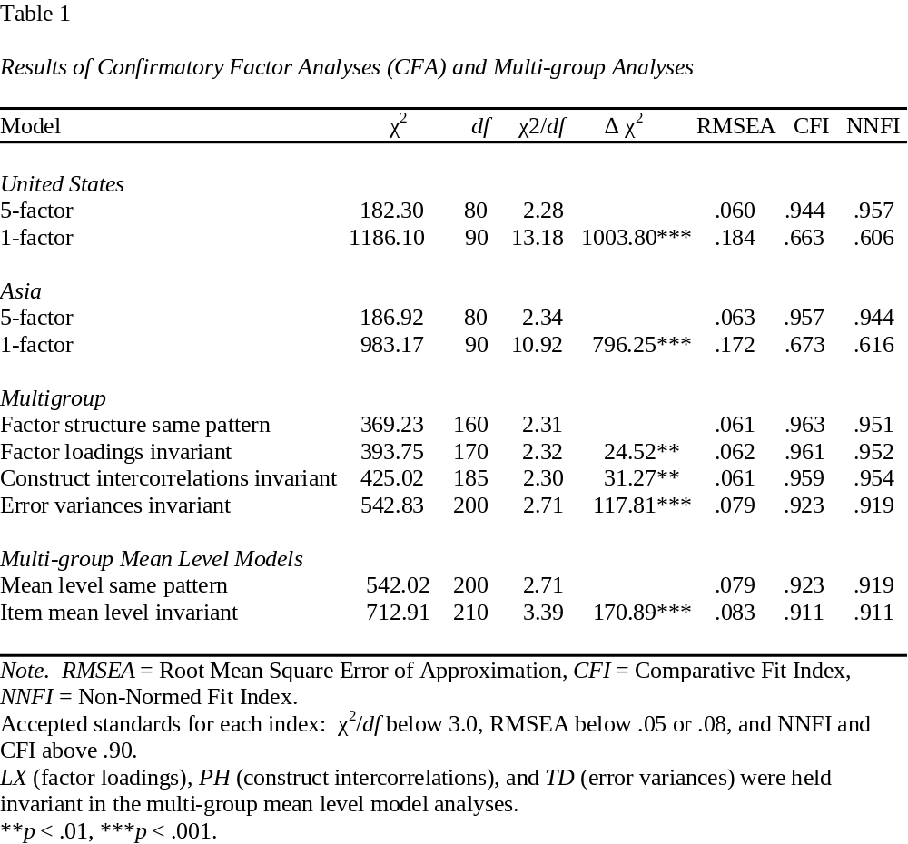

The Impact of Culture on Job Performance Measurement
Joseph Jones and Martin Lanik
Development Dimensions International

Organizations are increasing their use of standardized tests and other forms of assessments across national and cultural boundaries for administrative (e.g., selection decision-making) and development purposes. As use of these instruments increases, the fundamental models used in examining the validation of inferences made from these tools change. Additional factors may become more or less important to the relationship between how individual’s perceive or respond to test content and how that content can be used to make inferences that are valid and meaningful. In addition, factors that were previously important within a single culture or national boundary may interact with culturally-saturated factors, further altering previous understanding of validity.
One validity model that may be particularly vulnerable to the impact of culture is the criterion-related validation model. In its simplest form, this model consists of regressing a predictor of job performance (such as employee standardized test scores) onto criteria for job performance (such as supervisor perception of successful performance). While recent research and policy has examined the importance of ensuring the standardization across cultures of the predictor side of this equation, little research has examined the criterion side of the model across cultures.
Conceptually, performance assessment is an evaluative judgment that is influenced by a set of values, which likely differ across cultures. Recent research by Ployhart, Wiechmann, Schmitt, Sacco and Rogg (2003) suggests that while supervisors’ use and conceptualization of performance rating scales may be invariant across cultures, their actual ratings of job performance may differ. Similarly, Lam, Hui, and Law (1999) found country-level differences in the conceptualization of several dimensions of contextual performance. Both studies provide initial evidence that other factors likely to influence performance ratings, such as age, tenure, and the opportunity to observe ratees’ behavior, may have different impact across different cultures.
These findings highlight the increased complexity when conducting criterion-related validation studies across multiple cultures, and point to the need of careful consideration of various cultural influences on the criterion side. The influences may vary greatly across situations, but include factors such as job performance-specific translation issues, differences in the conceptualization of job performance, different rating tendencies of supervisors with different cultural background, and local performance assessment practices.
The research we will be presenting further extends the research of Lam et al. (1999) and Ployhart et al. (2003) by examining differences in predictor test scores and supervisor performance ratings across the US and Latin America (i.e., the Caribbean, Central, and South America). This research examines differences in supervisor ratings of employee performance in several Latin American countries and across multiple performance competency constructs. In addition, we explore the impact of supervisor rating variance on the relationship between performance ratings and standardized test scores. In essence, we attempt to answer questions of whether job performance is conceptualized differently across these cultural and geographic boundaries, what factors impact rater tendencies and biases, and how these factors influence the criterion-predictor relationship.
We examined a sample of 575 sales representatives and 168 supervisors spanning the pharmaceutical, food services, and financial industries across the US, Mexico, Brazil, and several other Latin American countries. Sales representatives were administered a 110 item test measuring constructs predictive of sales competencies. In addition, supervisors rated each sales representative on sales related competencies such as Negotiation, Customer Focus and Tenacity. Initial results suggest that the magnitude of correlation between overall and subscale test scores and overall and sub-factor performance may be impacted by cultural and geographic factors. For example, variance in overall performance rating severity and leniency across countries may account for differences in observed correlations with test scores. In addition, we observed differences across countries in supervisor self-ratings of familiarity, accuracy, and frequency of contact with the sales representatives. However, correlation and performance rating variance across countries and cultures also varied by the type of performance competency measured.
The current study provides evidence suggesting that frame of reference differences may lead to differences in ratings that may hinder the accurate estimation of the relationship between test scores and performance. In addition, this study indicates that differences in performance ratings across cultures may be impacted by the type of targeted competency, suggesting that generalized performance ratings may give a more adequate gauge of validity than individual performance competencies. Further, this research suggests that examination of cross-cultural meta-analytic validity of criterion-related inferences may need to take into account various additional cross-cultural factors. We conclude our presentation with practitioner implications of these results (for conducting multinational validation studies), limitations of the study and suggestions for additional research.
References
Lam, S. S. K., Hui, C., & Law, K. S. (1999). Organizational citizenship behavior:
Comparing perspectives of supervisors and subordinates across four international
samples. Journal of Applied Psychology, 84, 594-601.
Ployhart, R. E., Wiechmann, D., Schmitt, N., Sacco, J. M., & Rogg, K (2003). The cross-
cultural equivalence of job performance ratings. Human Performance, 16, 49-79.

